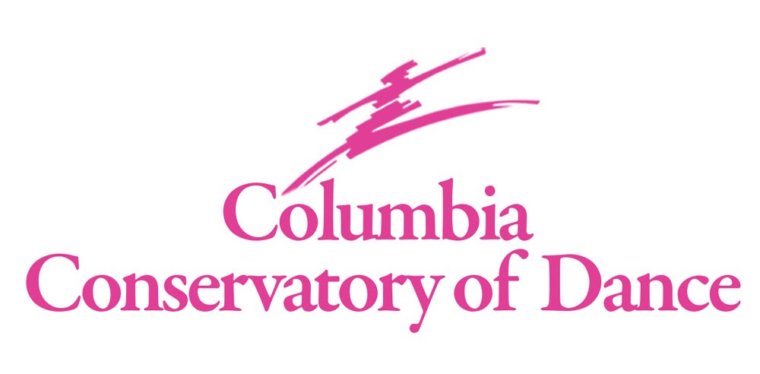

Mariclare Miranda & William Starrett
Co-Owners & Principal Instructors

Downtown Columbia – 1545 Main Street

(803) 252-0555
columbiaconservatoryofdance.com
ccdance1988@gmail.com

Ages 3 to Adult
Creative Movement, Pre Ballet, PreTap, Pre Jazz, Ballet, Pointe, Jazz, Tap, Lyrical & Contemporary

Classes begin Monday, August 14, 2023

Registration fee $25.00 (non-refundable) per student due on or before first lesson with completed registration form
Monthly tuition payable by ACH draft, credit card or check due on the 1st of every month.
August payment must be made with credit card, check or cash.
ACH draft will begin September 1, 2023.
Performance Fee $50, due with September tuition.
Costume Fee $75 per costume ordered, due with October tuition.
Unlimited Monthly Class Fee $475, private lessons & Daytime Program excluded.
5% discount for families with 3 or more registered dancers.
50% discount for male dancers, private lessons & Daytime Program excluded.
Late fee $25 charged on account balance after 10th of the month.
Returned check fee $35.

Classes per week | 30 min class | 45 min class | 60 min class | 90 min class
1 | $55 | $65 | $70 | $80
2 | $110 | $125 | $135 | $165
3 | $160 | $190 | $205 | $235
4 | $215 | $255 | $275 | $315
5 | $270 | $320 | $345 | $395
Class Monthly
Tuition

Private Lessons Available - Ms. Miranda or Mr. Starrett: $55.00 (30 minute Private)

CCD Staff Instructor: $50.00 (30 minute Private), $35.00 (per dancer Semiprivate)
*Payment for private lessons due at the time of lesson

Daytime Program – Supplemental ballet training for the Intermediate/Advanced dancer with studio directors’ acceptance. Classes are held Monday, Wednesday & Friday 12:30p – 3:30p. Monthly tuition $325.
*Start date for Daytime Wednesday, September 6, 2023

MARICLARE MIRANDA & WILLIAM STARRETT
CELEBRATING 35 YEARS OF PROFESSIONAL DANCE TRAINING
Classes begin Monday, August 15, 2023
William Starrett | Mariclare Miranda | Jordan Hawkins | Claire Rapp | Gabrielle Gardner

 | MONDAY | TUESDAY | WEDNESDAY | THURSDAY | FRIDAY
B  R  O  D  I  E | 12:30-3:30 Day Program  5:30-7:00 Ballet Jr/SubJr/B1 MM  7:00-8:00 Contemporary A GG | 4:45-5:30 Ballet Ball JH  C/B/Jr/SubJr  5:45-7:15 Ballet Jr/SubJr MM  7:15-8:30 CCBII | 12:30-3:30 Day Program  4:30-5:30 Ballet Teen Tech MM  5:30-7:00 Ballet Jr/SubJr/B1 WS  7:00-7:30 WS Private  7:30-8:30 Jazz A /B JH | 4:45-5:30 Ballet D2 MM  5:30-7:00 Ballet Jr/SubJr WS  7:00-8:30 CCBII | 12:30-3:30  Day Program  4:00-6:00  CODA
L  A  V  O  I  E | 3:30- 4:00 Creative Movement CR  4:00-4:30 PreTap CR  4:30-5:00 Pre Ballet 1 CR  5:00-6:00 Ballet C1 CR  6:00-6:45 Ballet D1 CR | 5:00-5:30 WS Private  5:30-6:30 Ballet B1 / C2 Tech WS  6:30-7:00 Ballet B1 / C2 Pt | 4:30-5:30 Ballet C1 Tech JH  5:30-6:00 Ballet Pre Pointe MM  6:00-7:00 Jazz C2/Teen JH  7:00-7:30 JH Private | 5:00-5:30 WS Private  5:30-6:30 Ballet B1/C2 Tech MM  6:30-7:00 Ballet B1/C2 Pt MM
S  P  O  H  R | 6:15-7:00 Int/Lyrical/Contemporary  B1/ C1 /C2 /Teen GG | 3:45-4:15 PreJazz JH  4:15-4:45 Pre Ballet 2 JH  4:45-5:30 Ballet D2 MM  5:30-6:15 Ballet D1 JH  6:15-7:00 Jazz D1 JH  7:00-7:30 Tap D1/D2 JH | 5:00-5:30 WS Private  5:30-6:00 JH Private | 4:30-5:30 Tap Int/Adv JH  A/ B1 / C2/ Teen  5:30-6:15 Jazz D2/C1 JH

Attire for Classes:

For all dancers, hair is not to be in the face or on shoulders. Female dancers are required to have hair in a bun for all ballet classes. A ponytail is acceptable for all other classes. Proper hair is part of the class attire and is strictly enforced. If a student does not have proper hair & clothing, they risk being excused from class. If assistance is needed, please let us know, and we will be happy to help. Just be sure to bring the supplies, i.e., hair pins, hair tie, hairbrush, hair net.
Please put student’s name in all dancewear and dance shoes!
No leg warmers or jewelry are allowed to be worn in class. Keep all valuables at home.

Creative Movement- Black or Pink leotard, ballet pink tights, pink leather ballet shoe

Pre Ballet 1, 2 - Black or Pink leotard, ballet pink tights, pink leather ballet shoe

Pre Tap 1, 2 - Black leotard, ballet pink Capezio #18 or tan tights, black patent tie tap shoes.
Male - Black jazz / sweat pant, solid color t-shirt, tap shoes Capezio CG17

Pre Jazz - Black or Pink leotard, pink or tan tights, tan jazz shoes

Ballet D 1, 2 - Black leotard, ballet pink Capezio #18, tights, pink leather ballet shoes

Ballet C1 - Black leotard, ballet pink Capezio #18, tights, pink leather ballet shoes with hot pink waist alignment belt

Teen Ballet – Black leotard, ballet pink Capezio #18, tights, pink leather ballet shoes with lilac waist alignment belt

Pre Pointe – Black leotard, ballet pink tights, previously designated waist alignment belt, pink pointe shoes

Ballet C2 - Black leotard, ballet pink Capezio #18, tights, pink leather ballet shoe, pink pointe shoe with light pink waist alignment belt

Ballet B1 - Black leotard, ballet pink Capezio #18, tights, pink leather ballet shoe, pink pointe shoe with royal waist alignment belt

Ballet B2 – Black leotard, ballet pink Capezio #18, tights, pink leather ballet shoe, pink pointe shoe with turquoise waist alignment belt

SubJr Ballet - Black leotard, ballet pink Capezio #18, tights, pink leather ballet shoe, pink pointe shoe with red waist alignment belt

Junior Ballet - Black leotard, ballet pink Capezio #18, tights, pink leather ballet shoe, pink pointe shoe with black waist alignment belt

Male (all levels of ballet): White t-shirt, black tights with white socks, white leather ballet shoe with white waist
alignment belt

*All waist alignment belts can be found online at Discount Dance Raindance ¾ Hip Alignment Belt Style No: 62S

Tap (all levels): Black or solid color leotard, tan or pink tights, black Capezio #CG09 tap shoes.

Jazz/Lyrical (all levels): Colored leotard of choice and dance/biker shorts are acceptable, tan Capezio tights #1916, tan Bloch shoes #S0401.

Male (all levels of jazz): Black jazz / sweat pant, solid color t-shirt, jazz shoes tan Bloch 401

Contemporary - Colored leotard and/or dance/biker shorts are acceptable, teacher will advise on shoes.

Office hours Monday – Thursday, 3:30pm – 7:00pm (closed Friday – Sunday)
- Website address – www.columbiaconservatoryofdance.com
- Email address – ccdance1988@gmail.com
- Studio phone 803-252-0555

Registration
- A completed registration form for every student is needed on file. This form, along with the registration fee, is due on or before the first lesson.
- The Conservatory charges a non-refundable $25 registration fee for each school year.
- You will be charged for the classes you have registered for, even if you do not attend, until we receive written notice of withdrawal. Written notice must be made in advance of any changes.

Fee and Payments
- Tuition is to be paid with a choice of ACH bank draft, a provided credit card or check, due the 1st of the month.
- All checks to be made out to Columbia Conservatory of Dance (CCD) and include the student’s name and what the payment is for in the memo section of the check.
- No refunds are given for registration, tuition, or commencement fees. After the 10th, the account will be considered delinquent and a late fee of $35 will be charged to your account. Payments will be credited to the oldest charges first if there is a balance due.
- Class fees are calculated on the cost for the entire school year, August 2023 – May 2024, paid in monthly installments.
- Tuition payments are required regardless of student’s attendance.
- To discontinue a class, notification is required in writing. Tuition payments will continue to be paid until we receive the notification.
- The Commencement Performance fee of $50 is due with the September tuition.
- Costume charges will be billed separately to be included with the October tuition.

Class Attendance
- Children should arrive 15 minutes before the scheduled class and be picked up promptly at the end of your dancers’ last class.
- Tardiness to class not only disrupts the class but also prevents the student from getting full benefit and the discipline expected. If the student is to be late to class, please contact the office to notify us so we may notify the instructor.
- If a student is to miss class, please contact the office. If a make-up class is wanted, please contact the office to check availability. Make-up classes are to be taken within two weeks of missed class. A refund is not given for missed classes.
- The Conservatory rewards students who attend every scheduled class. A medal for Perfect Attendance is presented during our Commencement Exercises. Make-up classes do not apply towards this medal, and eligibility begins the week of August 14, 2023.

Commencement Exercises
- Each year the Conservatory concludes the dance school year with our Commencement Performance, otherwise known as recitals.
- Performance fee helps to pay for the facility and various other things needed to highlight the dancers’ progress over the past year.
- Performance is typically around the middle to late May. Specific dates are TBA.

Parent Correspondence
- We welcome parents to visit our front lobby when waiting for your dancer.
- Parents may enter the dance classroom by invitation only. Classes run back-to-back, so it is very difficult for the instructor to have time to talk with you during class time. Please contact the office or the individual instructor to set up an appointment if you need to discuss any concerns.
- Please communicate with instructors about any health issues concerning your dancer.
- The Conservatory sends home notes occasionally and always posts information in the studio lobbies and on social media. You’re welcome to come in and check on a regular basis.
- Be sure to follow us on Facebook and Instagram to be current on all communications.
- Once registered, you will be invited to join our Remind group for text updates. You are highly encouraged to join this group for quick updates.

School Closings
In the event of inclement weather or other uncontrollable events, the studio will post on our social media outlets as well as sending out an email. No refunds will be applied to these situations.

Lost & Found
All items left in the studio will be placed in the lost & found bins and kept for 1 month, then donated to charities.

We ask that anyone entering and attending classes at the Conservatory monitor their health and that of their family members.
We encourage you to take appropriate precautions to prevent illness.
We ask that if you or your child are feeling unwell, please remain at home!

CCD Calendar for the 2023 – 2024 school year

First Day of Classes – Monday, August 14, 2023
Labor Day – Monday, September 4, 2023
Thanksgiving Break – Wednesday, November 22 – Friday, November 24, 2023, resuming Monday, November 27, 2023
Winter Break - Monday, December 18, 2023 – Tuesday, January 2, 2024, resuming Wednesday, January 3, 2024
Spring Break – Friday, March 29, 2024 – Friday, April 5, 2024, resuming Monday, April 8, 2024
35th Commencement Exercises (recitals) – Theater Dress Rehearsals - Tuesday, May 14, 2024
Theater Performances - Sunday, May 19, 2024

2023-2024 CLASS REQUIREMENTS FOR LEVEL D & UP:
Ballet D1, D2, Jazz D1, D2 & Tap D – 1 class required per week
Ballet C1 – 1 Ballet Technique class required per week, highly encourage 2 classes per week & Ballet Ball
Teen Ballet – 1 Ballet Technique & 1 Pointe class (if applicable), highly encourage Ballet Ball
Ballet C2 – 2 Ballet Technique & 2 Pointe per week & Ballet Ball
Ballet B1 – 3 Technique & Pointe per week & Ballet Ball
Jr & SubJr Ballet – 4 Technique & Pointe per week & Ballet Ball
*Levels C to Jr Ballet – Encouraged to also take a Jazz, Tap &/or Lyrical/Contemporary class to expand dance education

