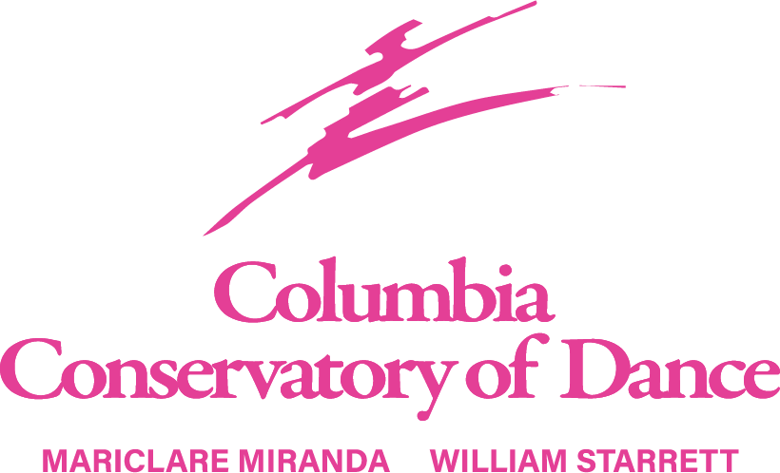
2024 -2025 SCHOOL YEAR
Ages 3 to Adult starting Monday, August 12, 2024
Creative Movement, Pre Ballet, Pre Tap, Pre Jazz Ballet, Pointe, Tap, Jazz, Contemporary, Modern, Adult Tap, Ballet Ball & Private Lessons
Registration fee $25 (non-refundable) per student & completed registration form due by 1st lesson.
Monthly tuition is payable by your choice of ACH bank draft or a Credit Card to be on file. All ACH & Credit Card drafts start September 3rd, due to August being pro-rated. The August tuition will need to be paid separately.
Monthly Class Tuition:
Classes per week | 30 min class | 45 min class | 60 min class | 90 min class
1 | $55 | $65 | $75 | $90
2 | $110 | $125 | $145 | $175
3 | $160 | $190 | $215 | $260
4 | $215 | $255 | $285 | $345
Private Lessons - 30 min lessons – Starrett & Miranda $55 per lesson, CCD Staff $50 per lesson. A credit card is required to be on file for private lesson payments to be charged prior to the lesson.
Day Program – Supplemental ballet training for the intermediate & advanced dancer. Acceptance into this program is determined by the studio director and may be required to audition. Classes are Monday’s 1:00-3:00 and Friday’s 2:00-4:00 with monthly tuition TBD. Start date is Friday, September 6.
5% Discounts available for families w/ 3 or more dancers & military families.
Performance fee $50 due with September tuition.
Costume fee $85 per costume ordered, due with October tuition.
Studio office hours are Monday – Thursday, 3:30 – 7:00pm. (Closed Friday – Sunday).
Website address www.columbiaconservatoryofdance.com
Email address ccdance1988@gmail.com
Studio phone 803-252-0555
Registration – We recommend sending in your registration form as soon as possible to hold your place in your desired class. A completed registration form for each student is required to have it on file. For current students, please confirm what we have on file is current and correct. Tuition and registration form & fee due before 1st lesson. Tuition is due the 1st of every month payable by ACH Bank Draft or Credit Card to be on file to run on the 1st of every month. After the 10th of every month, the account will be considered delinquent and a late fee of $25 will be added to your account. Payments made will be credited to the oldest charges first if there is a balance due. Tuition is calculated on the cost for the school year, August (pro-rated) – May and paid in monthly instalments. Tuition payments are required regardless of a student’s attendance. Payment for Private Lessons requires a Credit Card on file to run at the time of lesson. Refunds are not given for the registration fee, tuition fees and performance fees. To discontinue a class, notification is required in writing. Tuition fees will continue to be paid until we receive your notification.
Class Attendance: Students should arrive no earlier than 15 minutes prior to their scheduled class and be picked up no later than 15 minutes at the conclusion of classes. Please notify the office if you have difficulty with this. Tardiness to class not only disrupts the class but also prevents the student from getting full benefit of class. Multiple occurrences of tardiness may result in being dismissed from class. That’s why it’s best to notify us when your student will be late or absent. No refunds will be given for missed classes, illness, vacation, school closures or inclement weather. We will do our best to arrange a makeup class if requested but there is no guarantee one will be available. The Conservatory rewards students who attend all scheduled classes. An Attendance Medal is presented on stage at our Commencement Performances. Makeup classes are not eligible to count for this award.
Commencement Performances: We conclude our school year of dance with our annual Commencement Performances (recitals). These performances are typically mid to late May. Before the shows, we schedule a Photo Day, typically in April, for the dancers to have pictures taken in their costumes for group and individual photos. The group photos will be displayed at the studio for all to see in the future. Details will be provided once confirmed. Commencement Performance (recital) fee is $50 due with the September tuition. Costume charges will be billed in October.
Parent Correspondence: We welcome parents to visit our 1st floor lobbies when waiting for your dancer. We do ask if you have other children accompanying you in the lobbies, to please keep them busy and not running in the building. The 1st floor studio has a window to watch the dancing. On occasions we will open the 2nd floor for visitors to observe from the hallway. We will have an official “Open House” typically after the 1st of the new year. This is when family and friends are invited to observe sitting in the studio. If you wish to discuss a concern with a teacher, please make the front desk aware and you will be contacted to set up a meeting with the teacher. Please make us aware of any health issues concerning your dancer. Be sure to follow us on Facebook, Instagram and visit our website for updates throughout the year. You will also receive an invitation to join our Remind group for text updates.
School Closings: In the event of inclement weather or other uncontrollable events, the studio will post on our social media outlets.
Holiday & Important Dates Calendar:
Labor Day - Monday, September 2, 2024
Thanksgiving Break - Wednesday, November 27 - Friday, November 29, 2024 (return Monday, December 2)
Winter Break – Friday, December 20, 2024 – Friday, January 4, 2025 (return Monday, January 6)
Spring Break – Monday, April 14, 2025 – Friday, April 18, 2025 (return Monday, April 21)
36th Annual Commencement Performances – May 04, 2025 Recital Rehearsal Day May 18, 2025 Recital Performances

Class attire – for all dancers with shoulder length or longer, hair is to be pulled up off the face and shoulders. A bun is required for all ballet dancers at all levels. A ponytail is accepted for all other classes unless the teacher requests otherwise. Proper hair is a part of the class attire and is strictly enforced. Repeated disregard may result in being excused from class. If assistance is needed, please let us know and we will be happy to help. Be sure to bring the supplies needed for a bun which include a hairbrush, hair tie, hair pins and hair net. We know a bun can seem like a non-essential, but it is especially in ballet. Please put the student’s name on all dancewear and shoes. Legwarmers are not allowed to be worn in class but may wear before and after class. We ask no jewelry to be worn, better yet please keep all valuables at home as we are not responsible for missing items.
Creative Movement, Pre Ballet 1 & 2 – Leotard pink or black, ballet pink tights, pink ballet shoes
Pre Tap – Leotard black or pink, tights tan or ballet pink, black patent tie tap shoes. Boys – black jazz pants or sweatpants, solid color t-shirt, black tap shoes
Pre Jazz – Leotard black or pink, ballet pink or tan tights, tan jazz shoes. Boys same as Pre Tap w/ tan jazz shoes.
Ballet D1, D2 & C1 – Leotard black, ballet pink tights, ballet pink leather ballet shoes
Teen Ballet - Leotard black, ballet pink tights, ballet pink leather ballet shoes, lilac waist alignment belt.
Ballet C2 - Leotard black, ballet pink tights, ballet pink leather ballet shoes, pink pointe shoes if applicable, light pink waist alignment belt.
Ballet B1 - Leotard black, ballet pink tights, ballet pink leather ballet shoes, pink pointe shoes, royal blue waist alignment belt.
Ballet B2 - Leotard black, ballet pink tights, ballet pink leather ballet shoes, pink pointe shoes, turquoise waist alignment belt.
SubJr Ballet - Leotard black, ballet pink tights, ballet pink leather ballet shoes, pink pointe shoes, red waist alignment belt.
Sr/Jr Ballet - Leotard black, ballet pink tights, ballet pink leather ballet shoes, pink pointe shoes, white waist alignment belt.
Ballet for Male Dancers (all levels) – T-shirt white, black tights, white tube socks, white leather ballet shoes, black waist alignment belt.
*All waist alignment belts available online at discountdance.com Raindance ½ Hip Alignment Belt style No 60S.
Tap (all levels) – Leotard black or solid color, tan or pink tights, black Capezio #CG09 tap shoes.
Jazz /Lyrical (all levels) – Leotard color of choice, dance/biker shorts, tan tights or bare legs, tan jazz shoes.
Tap/Jazz/Lyrical/Contemporary for Male Dancers (all levels) – Black tap / jazz shoe/ teacher will advise on contemporary shoes, solid color sweatpants or shorts, solid color t-shirt.
Contemporary & Modern (all levels) - Leotard color of choice, dance/biker shorts, teacher will advise on shoes.

COLUMBIA CONSERVATORY OF DANCE, INC
2024-2025 CLASS SCHEDULE
 | MONDAY | TUESDAY | WEDNESDAY | THURSDAY | FRIDAY
B  R  O  D  I  E | 1:00- 3:00 Day Program  5:30-7:00 Ballet Sr/ Jr/ B2 - MM  7:00-8:00 Contemporary A/B - GG | 4:45-5:30 Ballet Ball C/B/Jr/SubJr - JH  5:30-7:00 Ballet Sr/ Jr - MM  7:00-8:30 CCBII | 4:30-5:30 Ballet Teen Tech - JH  5:30-7:00 Ballet Sr/ Jr /B2 - WS  7:00-7:30 WS Private  7:30-8:30 Jazz A /B - JH | 4:30-5:30 Ballet C1 Tech - MM  5:30-7:00 Ballet Sr/ Jr - WS  7:00-8:30 CCBII | 2:00-4:00 Day Program  4:30-6:00 CODA
L  A  V  O  I  E | 5:00-6:00 Ballet C1 - CR  6:00-6:45 Ballet D1 - CR | 4:45-5:30 Ballet D2 - MM  5:30-6:30 Ballet B2 / C2 Tech - WS  6:30-7:00 Ballet B2 / C2 Pt – WS  7:00-7:30 WS Private | 5:00-5:30 WS Private  5:30-6:00 Ballet Teen/C1 Pt - JH  6:00-6:45 Jazz C2/Teen - JH  6:45-7:30 Tap Teen/C1 - JH | 4:15-4:45 Pre Ballet 2 – JH  4:45-5:30 Tap A/B/C2 - JH  5:30-6:30 Ballet B2/C2 Tech - MM  6:30-7:00 Ballet B2/C2 Pt - MM
S  P  O  H  R | 3:30- 4:00 Creative Movement - CR  4:00-4:30 Pre Tap - CR  4:30-5:00 Pre Ballet 1- CR  6:00-7:00 Contemporary C/D - GG | 3:45-4:15 Pre Jazz - JH  4:15-4:45 Pre Ballet 2- JH  4:45-5:30 Ballet D1 - VW  5:30-6:15 Jazz D1 - JH  6:15-7:00 Tap D1/D2 JH | 4:30-5:30 Modern - TT  6:00-7:00 Adult Tap - SM | 4:15-4:45 Pre Ballet 1 – VW  4:45-5:15 Pre Jazz - VW  5:30-6:15 Ballet D2 - JH  6:15-7:00 Jazz D2/C1 - JH
Class schedule subject to change.

