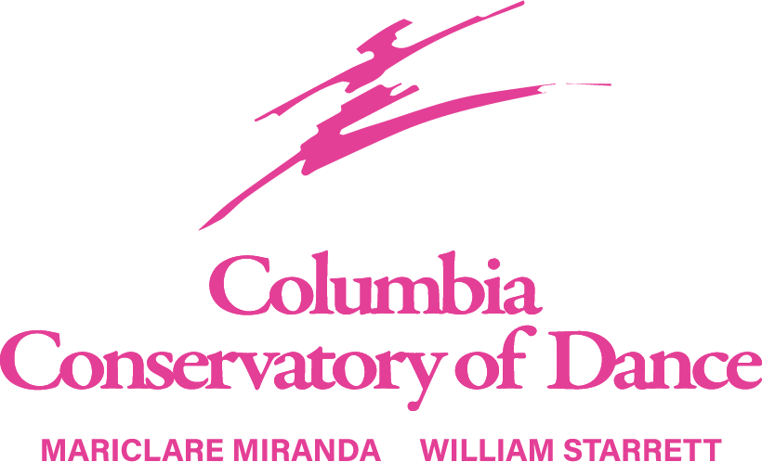
2026 -2027 SCHOOL YEAR
38th Year of Professional Dance Instruction
Official Home of South Carolina’s Premier Professional Ballet Company
South Carolina Ballet
Ages 3 to Adult
Classes start Monday, August 10, 2026
Creative Movement, Pre Ballet, Pre Tap, Pre Jazz Ballet, Pointe, Contemporary, Jazz, Lyrical, Tap & Private Lessons
Registration fee $25 (non-refundable) per student & completed registration form due by 1st lesson.
Monthly tuition - payable by your choice of ACH bank draft, Credit Card monthly draft, check or cash.
ACH bank drafts are drafted on the 1st of each month starting September 1st. August payment will need to be paid separately with check, cash or credit card.
Credit card monthly draft will be charged on the 1st of the month for class tuition.
Private lessons must be paid for at the time of the lesson using the credit card kept on file. If you prefer to pay by cash or check, payment must be made before the lesson. Private lesson may be cancelled if payment is not received.
Monthly Class Tuition:
Classes per week | 30 min class | 45 min class | 60 min class | 90 min class
1 | $60 | $70 | $80 | $95
2 | $115 | $135 | $155 | $190
3 | $170 | $200 | $230 | $275
4 | $225 | $265 | $305 | $365
Private Lessons - 30 min lessons – Starrett & Miranda $60 per lesson, CCD Staff $50 per lesson. Payment for private lessons is due at the time of the lesson.
5% Discounts available for families w/ 3 or more dancers & military families.
Unlimited tuition rate for group classes $485 monthly
Performance fee $50 due with September tuition & is non-refundable
Costume fee $90 per costume, due with October tuition. This fee is non-refundable once the costume is ordered.
Studio office hours Monday – Thursday, 3:45 – 7:00pm. (Closed Friday – Sunday).
Website address www.columbiaconservatoryofdance.com
Email address ccdance1988@gmail.com Studio phone 803-252-0555

Registration & Payment – We recommend sending in your registration form as soon as possible to hold your place in your desired class. A completed registration form for each student is required to have on file. For current students, please confirm what we have on file is current and correct. Tuition, registration form & fee are due before the 1st lesson. Tuition is due on the 1st of every month payable by ACH Bank Draft or Credit Card to be on file to run on the 1st of every month. After the 10th of every month, the account will be considered delinquent and a late fee of $30 will be added to your account. Payments made will be credited to the oldest charges first if there is a balance due. Tuition is calculated on the cost for the school year, August through May, and paid for in 10 monthly instalments. Tuition payments are required regardless of a student’s attendance; no pro-rating for missed classes or partial months. Payment for Private Lessons requires a Credit Card on file to run at the time of the lesson. If a credit card is declined more than 2x’s, cash or check is required. Refunds are not given for the registration fee, tuition fees, missed classes and performance fees. To discontinue a class, notification is required in writing. Tuition fees will continue to be paid until we receive your notification.
A minimum number of students is required for a class to remain open. In the event of low or high enrollment, we reserve the right to alter the class, whether it be cancelled or adding a class. The schedule is subject to change depending on enrollment.
Class Attendance: Students should arrive no earlier than 15 minutes prior to their scheduled class and be picked up no later than 15 minutes at the conclusion of classes. Please notify the office if you have difficulty with this. Tardiness in class not only disrupts the class but also prevents the student from getting full benefit from class. Multiple occurrences of tardiness may result in being dismissed from class. That’s why it’s best to notify us when your student is late or absent. No refunds will be given for missed classes, illness, vacation, school closures or inclement weather. We will do our best to arrange a makeup class if requested but there is no guarantee one will be available. The Conservatory rewards students who attend all scheduled classes. An Attendance Medal is presented on stage at our Commencement Performances. Makeup classes are not eligible to count on this award.
Cell phones are not permitted inside the dance studios.
Gum or food is not allowed in the dance studios. Only bottled water with cap allowed. There is a space with table and chairs on the 1st floor to accommodate eating.
Commencement Performances: We conclude our school year of dance with our annual Commencement Performances (recitals). These performances are typically mid to late May. Before the shows, we schedule a Photo Day, typically in April, for the dancers to have pictures taken in their costumes for group and individual photos. The group photos will be displayed at the studio for all to see in the future. Details will be provided once confirmed.
Commencement Performance (recital) fee, $50 due with the September tuition. Costume charges will be billed in October.
Parent Correspondence: We welcome parents to visit our 1st floor lobbies when waiting for your dancer. We do ask if you have other children accompanying you in the lobbies, to please keep them busy and not running in the building. The 1st floor studio has a window to watch the dancing. On occasions we will open the 2nd floor for visitors to observe from the hallway. We will have an official “Open House” typically after the 1st of the new year. This is when family and friends are invited to observe sitting in the studio. If you wish to discuss a concern with a teacher, please make the front desk aware and you will be contacted to set up a meeting with the teacher. Please make us aware of any health issues concerning your dancer. Be sure to follow us on Facebook, Instagram and visit our website for updates throughout the year. You will also receive an invitation to join our Remind group for text updates.
School Closings: In the event of inclement weather or other uncontrollable events, the studio will post on our social media outlets.
2026-2027 Holidays & Important Dates:
Labor Day - Monday, September 7
Thanksgiving Break - Wednesday, November 25 – 28 (return Monday, Nov 30)
Winter Break – Friday, December 18 – Friday, January 2 (return Monday, January 4)
Open House - TBD
Spring Break – Friday, March 22 - 27 (return Monday, March 29)
38th Annual Commencement Performances – TBD (May 2027)

Class attire – for all dancers with shoulder length or longer, hair is to be pulled up off the face and shoulders. A bun is required for all ballet dancers at all levels. A ponytail is accepted for all other classes unless the teacher requests otherwise. Proper hair is a part of the class attire and is strictly enforced. Repeated disregard may result in being excused from class. If assistance is needed, please let us know and we will be happy to help. Be sure to bring the supplies needed for a bun which include a hairbrush, hair tie, hair pins and hair net. We know a bun can seem like a non-essential, but it is, especially in ballet. Please put the students’ names on all dance wear and shoes. Legwarmers are not allowed in class but may be worn before and after class. We ask for no jewelry to be worn, better yet please keep all valuables at home as we are not responsible for missing items.
Creative Movement, Pre Ballet 1 & 2 – Leotard pink or black, ballet pink tights, pink ballet shoes
Pre Tap – Leotard black or pink, tights tan or ballet pink, black patent tie tap shoes. Boys – black jazz pants or sweatpants, solid color t-shirt, black tap shoes
Pre Jazz – Leotard black or pink, ballet pink or tan tights, tan jazz shoes. Boys are the same as Pre Tap w/ tan jazz shoes.
Ballet D1, D2 – Leotard black, ballet pink tights, ballet pink leather ballet shoes
Ballet C1 - Leotard black, ballet pink tights, ballet pink leather ballet shoes, pink pointe shoes if applicable, hot pink waist alignment belt.
Teen Ballet - Leotard black, short black skirt, ballet pink tights, ballet pink leather ballet shoes, lilac waist alignment belt.
Ballet C2 - Leotard black, short black skirt, ballet pink tights, ballet pink leather ballet shoes, pink pointe shoes if applicable, light pink waist alignment belt.
Ballet B1 - Leotard black, short black skirt, ballet pink tights, ballet pink leather ballet shoes, pink pointe shoes, royal blue waist alignment belt.
Ballet B2 - Leotard black, short black skirt, ballet pink tights, ballet pink leather ballet shoes, pink pointe shoes, turquoise waist alignment belt.
Master Ballet - Leotard black, short black skirt, ballet pink tights, ballet pink leather ballet shoes, pink pointe shoes, white waist alignment belt.
Ballet for Male Dancers (all levels) – T-shirt white, black tights, white tube socks, white leather ballet shoes, black waist alignment belt.
*All waist alignment belts available online at discountdance.com Raindance ½ Hip Alignment Belt style No 60S.
Tap (all levels) – Leotard black or solid color, dance/biker shorts, tan or pink tights, black Capezio #CG09 tap shoes.
Jazz (all levels) – Leotard color of choice, dance/biker shorts, tan tights or bare legs, tan jazz shoes.
Tap/Jazz/Lyrical/Contemporary for Male Dancers (all levels) – Black tap / jazz shoe/ teacher will advise on contemporary shoes, solid color sweatpants or shorts, solid color t-shirt.
Contemporary & Modern (all levels) - Leotard color of choice, dance/biker shorts, teacher will advise on shoes
Lyrical (all levels) - Leotard color of choice, dance/biker shorts, tan tights or bare legs, leather half-sole shoes
COLUMBIA CONSERVATORY OF DANCE 2026-2027 CLASS SCHEDULE
 | MONDAY | TUESDAY | WEDNESDAY | THURSDAY | FRIDAY
B  R  O  D  I  E | 5:30-7:00 Ballet Master/B/C2 MM  7:15-8:15 Contemporary A/B/C2 GG | 4:45-5:30 Ballet D1 JH  5:30-7:00 Ballet Master/B WS  7:00-8:30 SCBII | 4:30-5:30 Ballet C1 MM  5:30-7:00 Ballet Master/B WS  7:00-8:00 Jazz A/B/C2 JH | 4:30-5:30 Ballet D3 MM  5:30-7:00 Ballet Master/B WS  7:00-8:30 SCBII | 4:30-6:00  CODA REH  TBD – POP UP CLASS MONTHLY
L  A  V  O  I  E | 3:45-4:15 Pre Ballet 1 CR  4:15-4:45 Pre Tap CR  4:45-5:30 Ballet D1 CR  5:30-6:30 Ballet C1 CR | 5:30-6:30 Ballet C2 Tech MM  6:30-7:00 Ballet C2 Pt MM | 4:45-5:30 Ballet D3 GG  5:30-6:15 Lyrical D2/D3 GG  6:15-7:00 Jazz C1/D3 JH | 4:30-5:15 Ballet D2 GG  5:30-6:30 Ballet C2 Tech MM  6:30-7:00 Ballet C2 Pt MM
S  P  O  H  R | 5:30-6:15 Lyrical D1 GG  6:30-7:15 Contemporary C1 GG | 4:15-4:45 Creative Movement JH  5:30-6:15 Jazz D1 JH  6:15-7:00 Tap D1 JH | 3:45-4:15 Pre Ballet 2 JH  4:15-4:45 Pre Jazz JH  4:45-5:30 Ballet D2 JH  5:30-6:15 Tap C1/C2 JH | 4:45-5:30 Lyrical C1/C2 JH  5:30-6:15 Jazz D2 JH  6:15-7:00 Tap D2 JH

